Batch: A3 Roll No.: 1911034

Experiment / assignment / tutorial No. 03

Grade: AA / AB / BB / BC / CC / CD /DD

Signature of the Staff In-charge with date

TITLE :Multi-dimensional Arrays (Jagged Array)

AIM : Write a program which stores information about n players in a two dimensional array. The array should contain number of rows equal to number of players. Each row will have number of columns equal to number of matches played by that player which may vary from player to player. The program should display player number (index +1), runs scored in all matches and its batting average as output. (It is expected to assign columns to each row dynamically after getting value from user.
_____________________________________________________________________
Expected OUTCOME of Experiment:

CO2:Solve problems using Java basic constructs (like if else statement, control structures, and data types, array, packages, collection class).

Books/ Journals/ Websites referred:

1. Ralph Bravaco , Shai Simoson , “Java Programing From the Group Up” Tata McGraw-Hill.

2.Grady Booch, Object Oriented Analysis and Design .
_____________________________________________________________________
Pre Lab/ Prior Concepts:

Arrays
Multi-Dimensional Array:
10 12 43 11 22
20 45 56 1 33
30 67 32 14 44
40 12 87 14 55
50 86 66 13 66
60 53 44 12 11
A multi dimensional array is one that can hold all the values above. You set them up like this:
int[ ][ ] numbers = new int[6][5];
The first set of square brackets is for the rows and the second set of square brackets is for the columns. In the above line of code, we're telling Java to set up an array with 6 rows and 5 columns.
aryNumbers[0][0] = 10;
aryNumbers[0][1] = 12;
aryNumbers[0][2] = 43;
aryNumbers[0][3] = 11;
aryNumbers[0][4] = 22;
So the first row is row 0. The columns then go from 0 to 4, which is 5 items.
Class Diagram:
Class:
public class Exp03();
Method:
public static void main(String args[])
Variables:
int n , i, j,p,m, total, avg,k,max,count,temp;

Implementation details:
import java.util.*;

public class Exp03
{
public static void main(String args[])
{
int n , i, j,p,m, total, avg,k,max,count,temp;
Scanner sc = new Scanner(System.in);

System.out.println("Enter the number of players");

n = sc.nextInt();
int arr[][] = new int[n][]; //declaring blocks of memory for the array

System.out.println("Enter the number of matches played by each player in a successive order");

for(i=0;i<n;i++)
{
p = sc.nextInt();
arr[i] = new int[p]; //for the i'th row in the array , we need to allocate p blocks of memory , for the coloumns
}

for(i=0; i<n;i++)

{
k=i+1;
System.out.println("Enter the scores of the player " + k + " in all his matches");
for(j=0;j<arr[i].length;j++)
{
//as the number of coloumns for each row will be different , this loop will run a different number of times for each row

arr[i][j]= sc.nextInt();
}
}
max=0;
for(i=0;i<n;i++)
{
count = 0;
for(j=0;j<arr[i].length;j++)
{
count++;
}
if(count>max)
{
max = count;
}
}

System.out.println("Scoreboard");
System.out.print(" ");
for(i=1 ; i<=max ; i++)
{
System.out.printf(" m"+i);
System.out.print(" ");
}
System.out.println("Average");

for(i=0;i<arr.length;i++)
{total=0; avg= 0;k=i+1;temp=0;
System.out.print("Player" +(i+1));
for(j=0;j<arr[i].length;j++)
{
total = total+arr[i][j];
System.out.print(" "+arr[i][j]);
}
if(arr[i].length<max)
{
temp = max-arr[i].length;
}

while(temp!=0)
{
System.out.print(" ");
temp--;
}

avg = (total)/arr[i].length;
System.out.println(" " +avg);
}

}

}

Output:
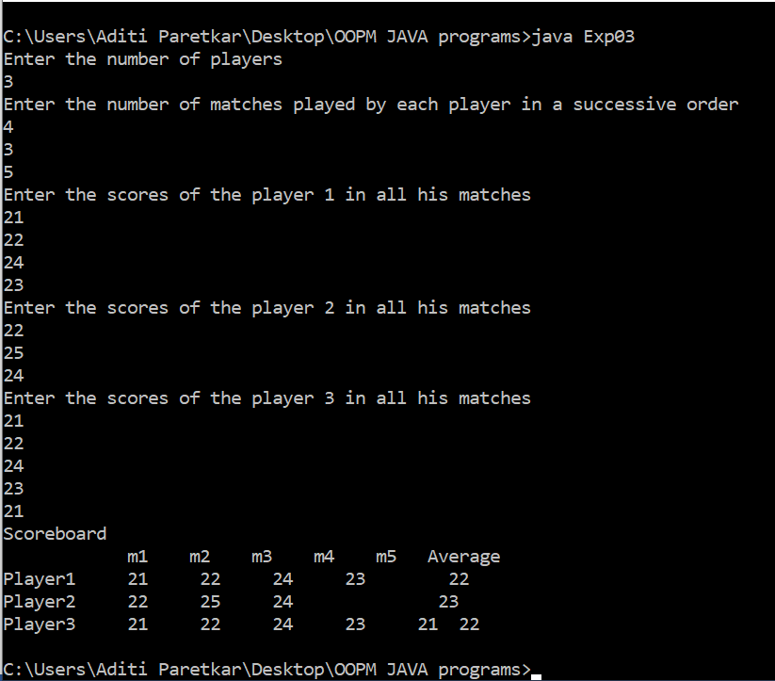
Conclusion: In this experiment , we have learnt about the different types of arrays in java , i.e Single Dimensional Arrays, Multidimensional Arrays and Jagged Array(i.e. Arrays having different number of coloumns for each row). We have learnt about array instatiation in java , and allocation of memory to the individual objects. Through this experiment , we have also successfully learnt how to implement Jagged Array in Java

Post Lab Descriptive Questions

Q.1 Which of the following statements are valid array declaration?
(A) int number();
(B) float average[];
(C) double[] marks;
(D) counter int[];

(i) (D)
(ii) (A) & (C)
(iii) (A)
(iv) (B)&(C)

Ans: iv) B and C

Q.2 Consider the following code
int number[] = new int[5];
After execution of this statement, which of the following are true?
(A) number[0] is undefined
(B) number[5] is undefined
(C) number[4] is null
(D) number[2] is 0
(E) number.length() is 5

(i) (C) & (E)
(ii) (A) & (E)
(iii) (E)
(iv) (B), (D) & (E)

Ans: iv) B, D and E

Q.3 What will be the content of array variable table after executing the following code?
for(int i = 0; i < 3; i + +)
for(int j = 0; j < 3; j + +)
if(j= = i) table[i][j] = 1;
else table[i][j] = 0;

A). 0 0 0
0 0 0
0 0 0

B). 0 0 1
0 1 0
1 0 0

C). 1 0 0
1 1 0
1 1 1

D) 1 0 0
0 1 0
0 0 1
Ans: D

Date: Signature of faculty in-charge

